User stories

1.A user story is a general explanation , of a software feature written from the perspective of the end user.It’s an end goal, not a feature, expressed from the software user’s perspective.

outline the desired outcome.

"customers" don't have to be external, they can also be internal customers or colleagues within your organization who depend on your team.

2.After reading a user story, the team knows why they are building, what they're building, and what value it creates.

3. user stories in agile methodology is scrum and kanban.

In scrum, user stories are added to sprints.

Kanban teams pull user stories into their backlog and run them through their workflow.

**User stories Benefits**

1.Stories keep the focus on the user,collection of stories keeps the team focused on solving problems for real users.

2.Stories enable collaboration. With the end goal defined, the team can work together to decide how best to serve the user and meet that goal.

3.Stories drive creative solutions.

User stories are expressed in a simple sentence, structured as follows:

“As a [persona], I [want to], [so that].” breaking down

"As a [persona]":

Who are we building this for? We understand how that person works, how they think and what they feel.

“Wants to”:

What is it they’re actually trying to achieve?

“So that”: What’s the overall benefit they’re trying to achieve?

==================================================================

**User story example**

**As** a Spotify podcast listener

**I want** to save podcasts as my favourites

**so that** , I can create my own custom list of favourite podcasts

USER STORY FORMAT

As a <user role> -----------> WHO

I want to <action> ---------> WHAT

So that <value> ---------> WHY

**How to create a good user stories**

INVESTING IN USER STORIES

It helps us to create a more meaningful user stories.

Independent – stories should be independent of one another so that each of them can be developed and delivered

Negotiable - Stories should be discussable and should be open for negotiation

Valuable- the story must add value to the customer

Estimable- The stories must be estimable and can be divide into tasks

Small- Stories should not be too long. So that it can handle better

Testable- They should have acceptance criteria to check whether we fulfilled the customers needs or not.

**Acceptance Criteria**

Acceptance Criteria are the conditions a software must meet to be accepted by a user, a customer, or other systems.

Structure as follows : Given/ When/ Then

**Given**- context or pre- condition

**When** - some action is carried out

**Then** – observable outcome and expected results

**Example for Acceptance Criteria**

**Given** the spotify app displays podcats

**When** I click the favourite icon that is displayed by each individual podcast

**Then** the podcast gets saved

And It is displayed in my favourite list

In software development, the person who decides what kind of software or product is to built is known as the Product Owner.

The people who build what is asked asked by the Product Owner are known as the Development Team

A Scrum Team works in Sprints.

A sprint is a time-box of one month or less

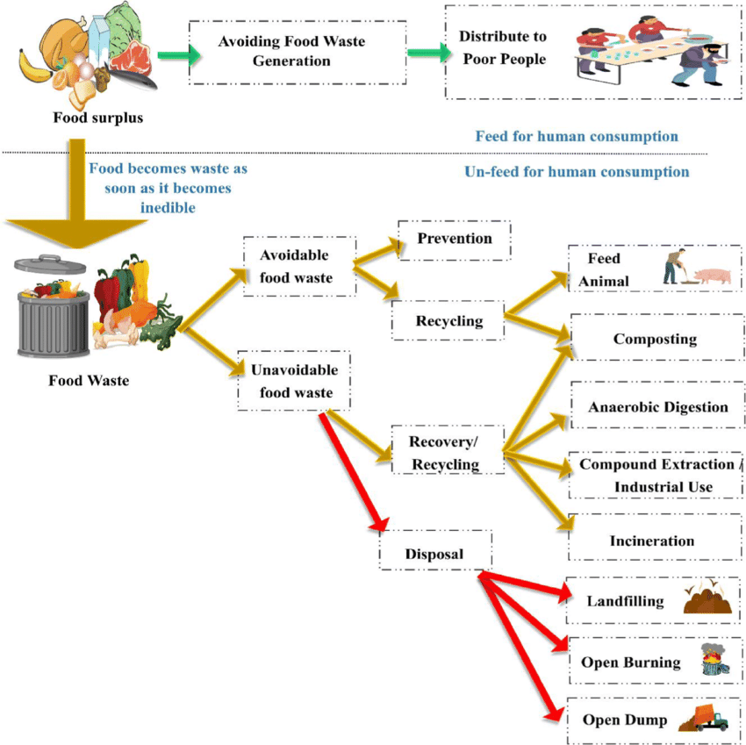

|  |  |
| --- | --- |
| Food Excess | As a donar, I want excess food so that I can distribute to the people |
| Avoidable food waste | As a donar, I want Avoidable food waste so that I can recycle it by composting and feeding animal  As a donar, I want Avoidable food waste so that I can prevent |
| Unavoidable food waste | As a Recycling specialist , I want Unavoidable food waste so that I can recover it by anaerobic digestion  As a Recycling specialist, I want Unavoidable food waste so that I can recycle it for industrial purpose |
|  |  |